Visualization Set Up Instructions

The following set up procedure (10 steps) should be followed to properly carry out the visualization of the C++ Cell-DEVS minefield mapping simulation:

- Install Blender from http://download.blender.org/release/Blender2.43/blender-2.43-windows.exe
- Install Python version 2.4 from http://www.python.org/ftp/python/2.4.4/python-2.4.4.msi
- Place mineclear3blocks.blend in C:\Program Files\Blender Foundation\Blender\.blender
- Place minefield_gui_v11.py in C:\Program Files\Blender Foundation\Blender\.blender\scripts. **Delete any previous gui scripts from either P. Castonguay (ac_evac_gui.py)
or E. Poliakov (gui.py).
- Place MineClear4Robots.ma, MineClear4Robots.val, and MineClear4Robots.log in
C:\Program Files\Blender Foundation\Blender\.blender
- Open mineclear3blocks.blend. This can be done one of two ways:
  - by double clicking on the file in the C:\Program Files\Blender Foundation\Blender\.blender folder; OR
  - in Blender, from the File menu, select Open and the proper file.
- Load the CD++ Simulations script. See the following screen capture.
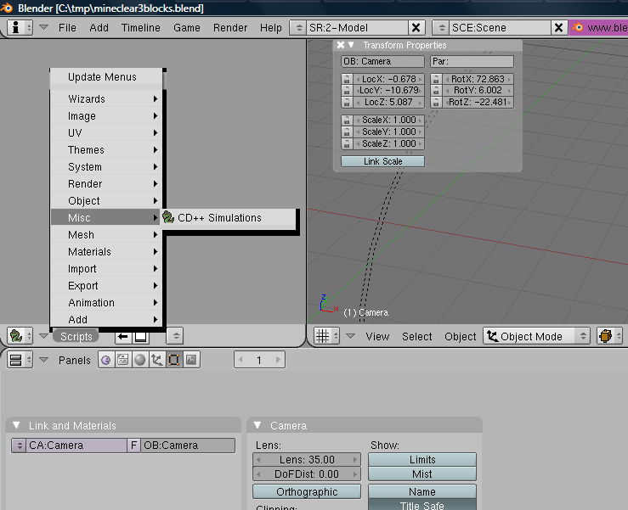
1
2
3

- In the script GUI, select MineClear4Robots.ma and MineClear4Robots.log by browsing the .blender folder, if they are not already selected. See the following screen capture.
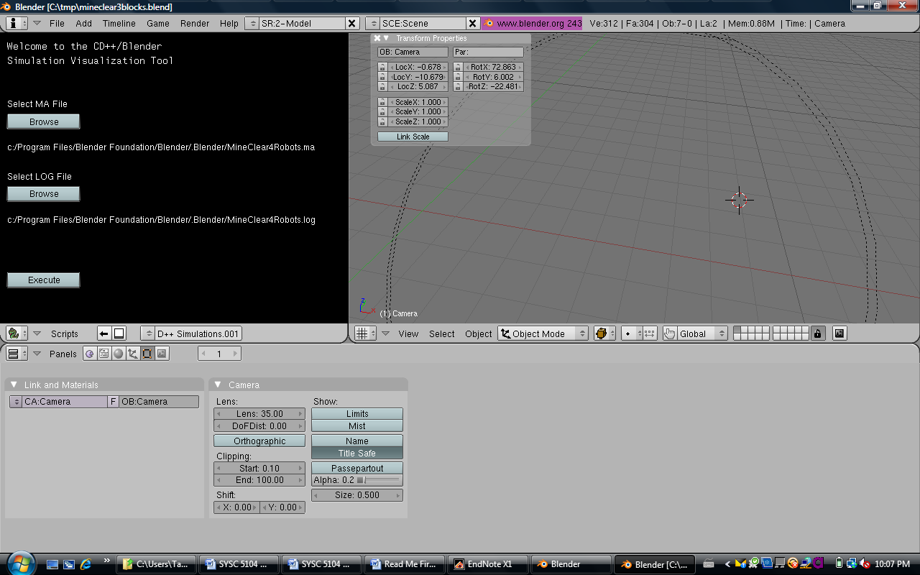

- Hit the Execute button in the script GUI

- Watch the 3D visualization ☺

